Advance Cyber Security Serial No 09

Assignment 4

shreyyash

2020

March

Contents

1. Assignment 4: Basic Linux Disk Usage Cmd
   1. Introduction………………………………………. 3
   2. Answer 1………………..…………………………. 3
   3. Answer 2………….…….…………………………. 4
   4. Answer 3………….…….…………………………. 5
   5. Answer 4………….…….…………………………. 6

List of figures

1.2.1 Figure 1: *du –ah in the installer directory* ………….…..………….… 3 1.3.1 Figure 2: *du –sh \* |sort –h in the installer dir…….*..………………... 4

1.4.1 Figure 3: *sudo du – h –d 1 –x / in root dir.* ..…………………. ……. 5

1.5.1 Figure 4: *Disk usage after excluding a file* ………………...………… 6

CHAPTER 4

Assignment 4: Basic Linux Disk Usage Cmd

* 1. Introduction

The /var/log/installer folder has been for testing the data storage commands.

* 1. Answer 1

1.2.1 du –ah

du - disk usage

a - all

h - human readable

This cmd lists all the files in the directory and gives a total usage at the bottom in human readable format.

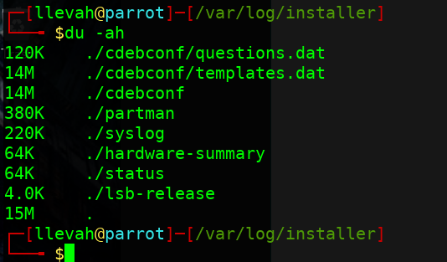

*Figure 1: du –ah in the installer directory*

* 1. Answer 2

1.3.1 du –sh \* |sort –h

du - Disk usage

h - human readable

sort - sort by size

\* - all

This cmd lists all the files in the directory and gives a total usage at the bottom in human readable format.

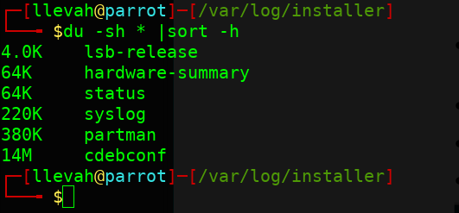

*Figure 2: du –sh \* |sort –h in the installer directory*

1.4 Answer 3

1.4.1 sudo du – h –d 1 –x /

This command can be broken down as follows

*h – human readable*

*d 1 - depth = 1*

*x / - exclude other dirs*

Running this cmd in root dir gives the following output

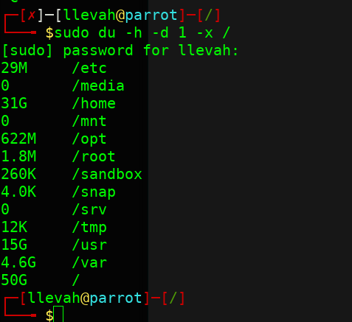

*Figure 3: sudo du – h –d 1 –x / in root dir*

1.5 Answer 4

1.5.1 du –a exclude==status

This command can be broken down as follows

du - disk usage

-a - all

--exclude==<filetype> - exclude a particular file type

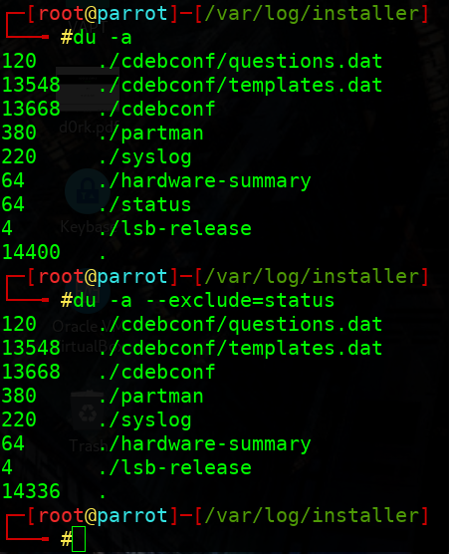

*Figure 4: Disk usage after excluding a file*